Chain Plates – To do or not to do – that is the question, that is the question, that is the question!
When I bought Beaujolais (44WO #186 Nov ’79) in 2005, I had read about the chain plate issue on the forum and therefore inspected them closely; well, as closely as anyone can visually get to their somewhat concealed locations behind lockers and wonderfully finished woodwork.
They looked okay. Yes, there was rust but it looked to be only superficial. The previous owner assured me that the signs of damp in the lockers were from historical issues and that the boat was now dry.
For four years, during both Laying Up and Fitting Out, I twisted my body into the most unimaginable and certainly not alluring positions in order to get my mirror-on-a-rod, torch beam and eye all in conjunction to look at that top bolt, tang welds and the bottom six bolts.
Every year, all looked pretty much the same. The lockers were still wet, re-sealing the tangs as they passed through the cap rail made the predictable ‘no difference at all’. But and this is really important, they still looked to be ok, structurally!
In January this year (’09), I did my regular Fitting Out checks and again, all looked ok. We then cruised from Guatemala’s Rio Dulce via Honduras to Columbia, on to the San Blas and finally Bocoas Del Toro in Panama where we laid her up.
And now the story really starts. During the Laying Up process, I noticed a small crack on the tang of the portside cap (masthead) shroud chain plate. I looked again, and again and yet again but I finally had to accept that it really did look as if it was cracked and no amount of looking would change that fact.
I went back to the Forum archives, read Ron’s (Memory Rose), Dave’s (Soggypaws) and other reports and reluctantly accepted that the answer to the big question was definitely yes, To do!
Conversations with both Dave and Ron were very helpful and put me in contact with Rick Heim of Gulf Coast Industrial who by now has made I think, six sets of a new design of chain plate; I think I know who designed them originally but as I am not 100% sure, I will not name him. Please feel free to name yourself in a reply as you certainly deserve the credit.
I bit the $3.200 bullet for the plates, special bolts and what turned out to be 100 man hours involved in the removal of the old and fitting of the new. Also I dealt with my undue concern that all that wonderful woodwork would never look the same again after being removed and refitted. It looks and is for the most part, untouched.
Decision made. Move forward. From now it all gets better; most steps were forward with only a few haltering moments and some really good surprises, but they were managed.
I apologise if this sounds long winded and a tad emotional, but it has been! We have a lovely boat, fantastic interior and I simply didn’t want to spoil the wonderful woodwork or damage the gelcoat, make big gaping holes in the cap rails, rip out the lockers and not get them back looking they same or damage the wood and not be able to match it. As in life generally, once started, there’s no going back. So on we went.
THE WORK can be broken down into three distinct sections:
1. Removal and Fitting and the Problems to overcome
2. The Solutions
3. The unexpected Extras
- The Problems to overcome
Top bolt access
Curved slot in bolt head
Stopping the bolt from turning
When the slot is all chewed up – what then
- The Solutions
Ultimate recourse is through the cap rail
Angle grinder
Heat helps
THE TOOL

- The unexpected Extras
The number and variation of tools needed
The wood could be rotten or break, you may need to be able to rematch it
Resealing the woodwork – teak, not white sealant
The Pain! – those crazy positions do hurt- if its not for you then get help
Don’t even think you can do this from a dinghy. Best is a floating dock (pontoon) second a fixed dock but the tides will really affect you work windows.
TIME and woodwork skill if you want it to look as good afterwards as it did before.

I want to make one more extremely important point.
During this work, many people spoke to me and discussed the problems at length. It was clear that this is an issue for ALL 20+ year old boats with internal or concealed chain plates. I specifically heard of a Gulfstar and a Morgan which had the same problem. Others readily admitted to ignoring theirs because they were too hard to get to and were too expensive to replace. Another person I spoke to told of an actual dismasting (not a CSY) he knew of which was due to chain plate failure and the insurance would not pay out a cent as it was clearly caused by a lack of responsible maintenance.
The new plate design is excellent in all respects and could easily become the recognised norm for the CSY marque as it suits the boat’s traditional lines perfectly.
They fit perfectly between the rubbing strake and the cap rail, the latter needing minimal work. Most important though is that the forces pull the plate into the hull as opposed to away from the hull on the internally mounted version.
At time of posting, the following are the cost and contact details for Rick Heim, truly an excellent and professional plate manufacturer:
Set of 6 (six) chain plates for a CSY 44 $2,500.00
1. Stainless Steel 316L ½” thick
2. Tang to be 4” wide with 2 holes and bent to angles as previously supplied for other CSY 44WOs
3. Bolts to have hex heads and countersunk flush with surface of plate
4. Plates will be polished and buffed to a mirror finish.
5. Other details as per drawing
Electro polishing $ 175.00
Fastners - 316:.
54 off Hex head Bolts 1/2-13 X 2-1/2" 316 $965.00 per 100 (approx price) $ 521.10
54 off 1/2" flat washers -- 316 $67.00 per 100 (approx price) $ 36.18
54 off 1/2-13 Nylock Nuts – 316 @ $106.00 (approx price) $ 57.24

Rick Heim
Gulfcoast Industrial Repair
4924 18 th Ave S.
Gulfport , Fl 33707
727-328-2346
rheim97247@aol.com
FAX 727-328-0143

The following pictures tell the story:
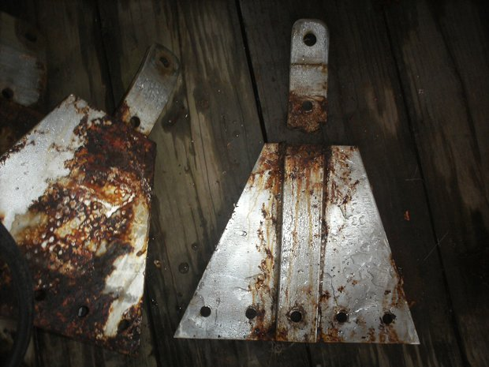
Two old plates. The one on the right was the one with the tiny crack. I actually snapped it ion two with my hands.
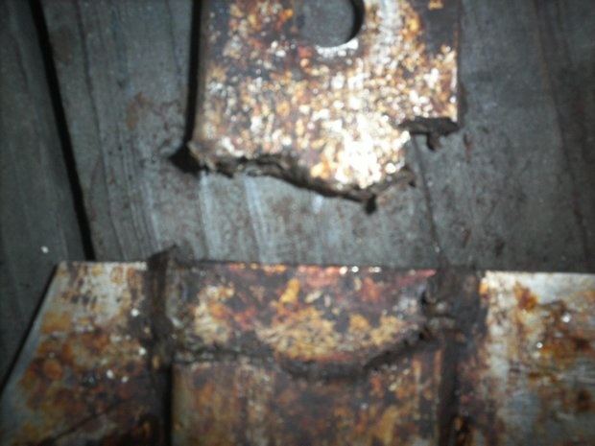
Close up of the broken plate

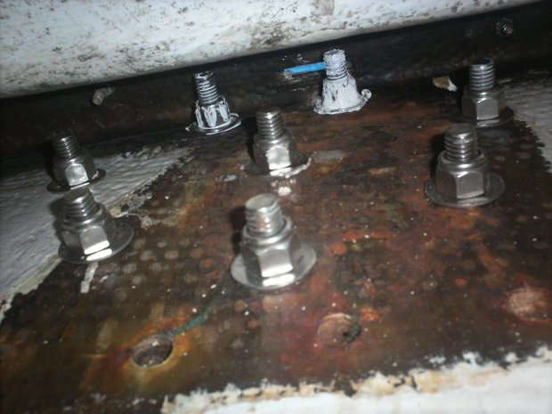
The old plate holes and cap rail slot with blue tape over it, and the new plate bolts

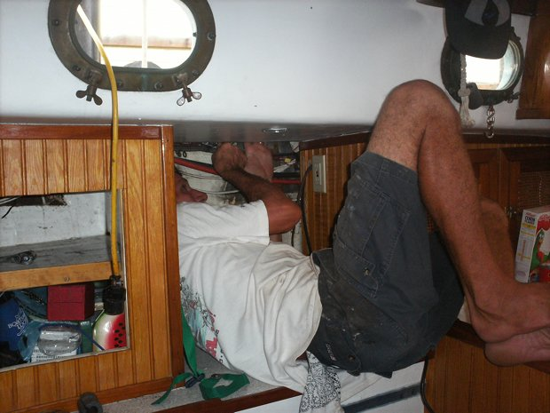
This was one of the easier ones to get to.
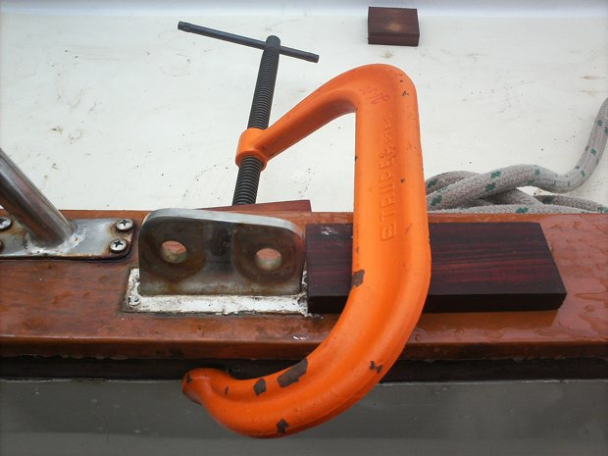
The Tool in position. Note the sacrificial block to protect the cap rail

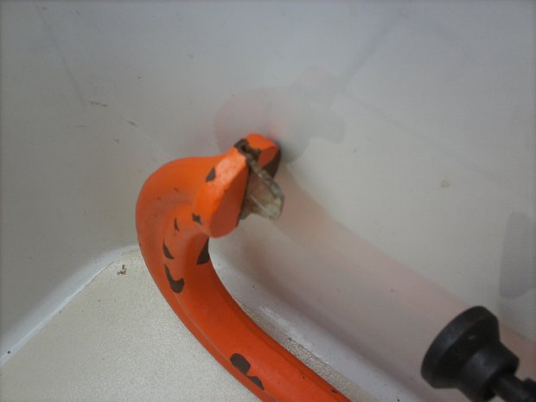
The Tool is a C or G clamp with a slot cut into it to accept a fashioned bit. The bit edge is curved because the bolt slots had been manufactured using a rotary disc instead of a milling machine

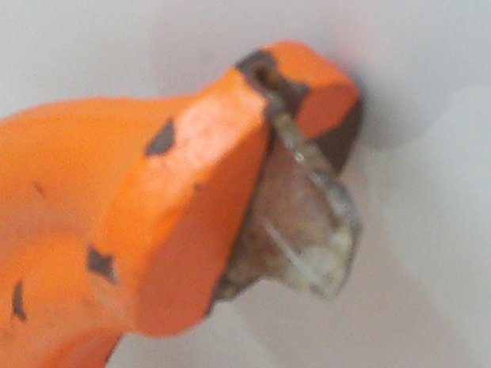Close-up of the bit
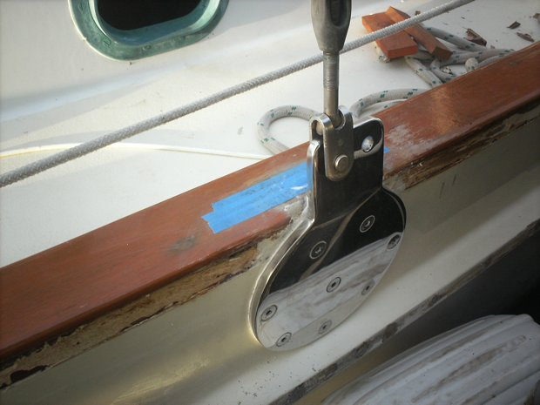The new plate on the outside of the hull
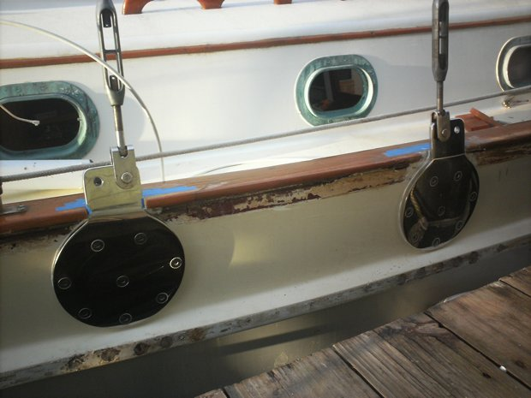The new plates in situ. Note the old plate holes in the rubbing strake. Also not the extra holes on the Tangs. I use the forward one for attaching the Spinnaker pole downhaul and the aft one for attaching the Main boom Preventer.

